Table of Contents
- How do I register my credit card?
- Trouble with seeing VISA screen? White screen?
- How can I view my transactions?
- Can I download my transactions?
- How do I view my statements?
- How do I enroll in eStatements?
- How do I make a payment?
- What is the payment address?
- How can I view my payment history?
- How can I view my existing cards and add additional cards to this account view?
- How can I setup alerts on my credit card?
- ADDITIONAL INFORMATION
- How do I register my credit card?
To enroll in the VISA credit card online portal, members must login to their online banking account and complete a one-time enrollment registration process. You will need to provide your account number, social security number and branch where the account was opened. For enhanced security, you will need to answer three (3) challenge questions, choose a security phrase and security image.
- Please login to your online banking account
- Click on the Credit Cards icon
- The Registration Screen appears
- Enter the requested information in the fields:
  - Name on Credit Card
  - Profile email address
  - Verify Profile email address
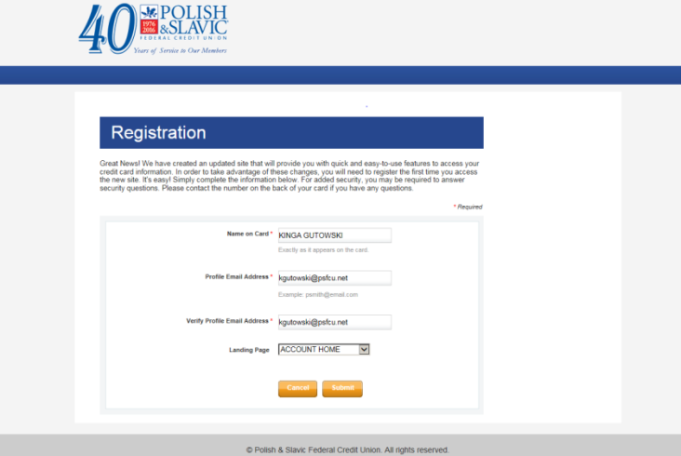
- Click Submit
- Accept First-time Terms and Conditions by checking off the box
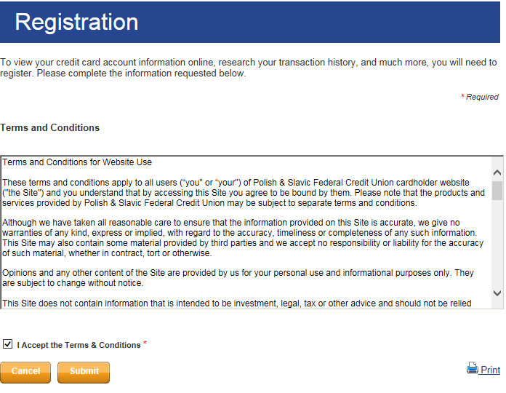

- The member will be automatically directed to their personalized credit card information profile

- Trouble with seeing VISA screen? White screen?
  - Member must disable pop-up blocker
    - Chrome
      - Open Chrome.
      - In the top-right corner, click the Chrome menu
      - Click Settings.
      - Click Show advanced settings.
      - Under "Privacy," click Content settings.
      - Under "Pop-ups," select Do not allow any site to show pop-ups (recommended) or Allow all sites to show pop-ups.
    - Safari
      - Open Safari
      - Click the Safari Menu
      - Click “Block Pop-up Windows”
or
      - Open Safari
      - Click on Preferences, Security
      - Uncheck Block pop-up windows
    - Firefox
      - Open Firefox
      - Select Content
      - Disable pop-up windows
    - Internet Explorer
      - Open Internet Explorer.
      - Click the Tools button, and then click Internet options.
      - On the Privacy tab, under Pop-up Blocker, click Settings.
      - In the Pop-up Blocker settings dialog box, clear the “Turn on Pop-up Blocker”
      - Click OK.

- How can I view my transactions?
  - There are two ways to access the View Transactions screen click the:
    - View Transactions link under the card information
    - Statements & Activity and then View Transactions
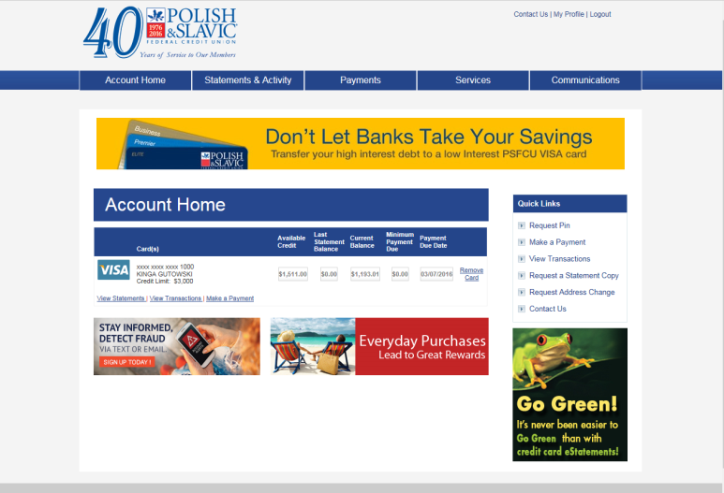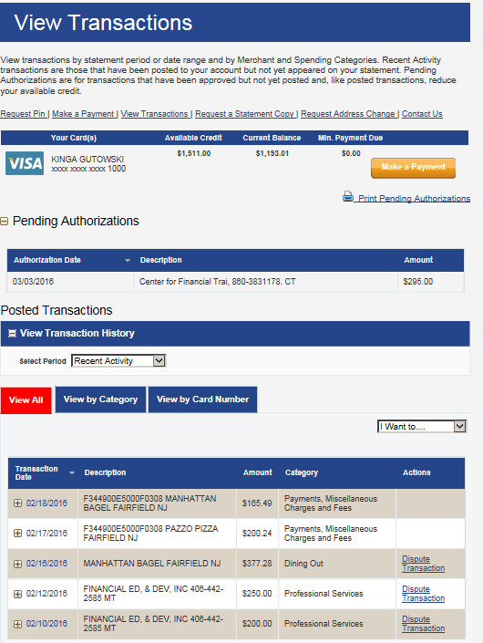

- No matter how many transactions are sorted, the same fields display on screen:
  - Transaction date
  - Description
  - Amount
  - Category
  - Actions

- Can I download my transactions?
- Members are able to download transactions for other uses, such as saving for future reference. The “I want to” dropdown allows your cardholder to download transactions as either a comma separated value (CSV) file, or an Excel (XLS) file or to print. Using either link allows cardholders to download and save the set of transactions currently being viewed.

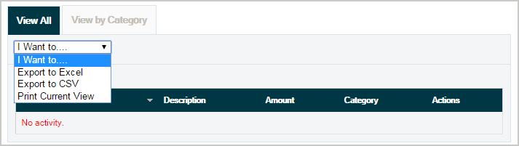
- How do I view my statements?
- To view statement, hover mouse over “Statements and Activity” and select “View Statements”
- A summary of the current statement will be displayed
- The first statement will be available with the March cycle
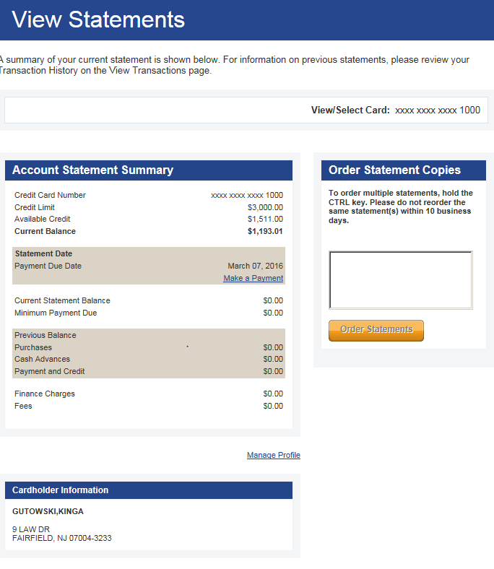
  - This section displays a summary of your cardholder’s current statement and at-a-glance information including the following features:
    - Current balance
    - Payment due date
    - Finance charges
    - Link to “Make a Payment” online
    - Cardholder information including primary and secondary cardholder names and address on record for the card account
    - Ability to order statement copies
- How do enroll in eStatements?
  - To enroll in VISA eStatements, hover mouse over “Statements and Activity” and select “Go paperless”
  - If the member is not currently enrolled in eStatements, a link to enroll eStatements displays. Clicking the link takes the cardholder to a new page to complete the enrollment process. Enrolling in eStatements turns paper statements off for the cardholder.
  - If the member no longer wants to receive eStatements, the cardholder clicks the “Unenroll” from eStatements link to deactivate the service. Clicking the link takes the cardholder to a new page to complete the deactivation process. Once the service is deactivated, receiving paper statements resumes.
  - eStatements will be available beginning the March 2016 cycle. Previous statements will not be available.
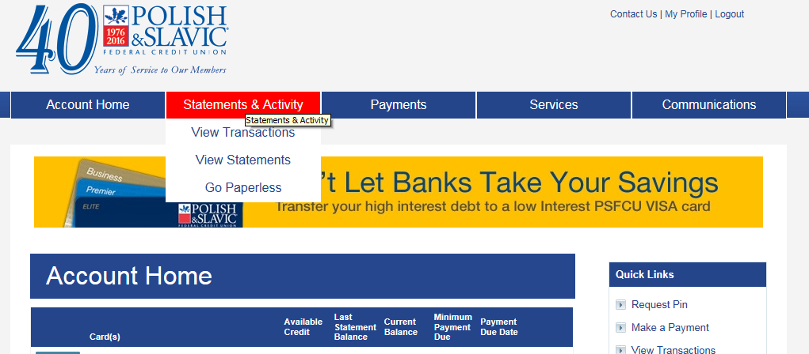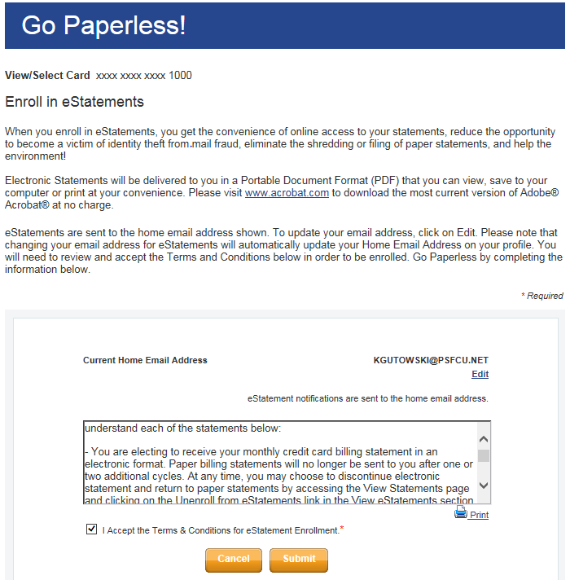
- How do I make a payment?
  - To make a payment, select “Payments” and “Make a Payment”
  - Members may make a one-time payment or setup automatic payments
  - Payments may be made from savings or checking accounts
  - Currently, once a cardholder completes the payment transaction, it does not show anywhere until it is processed the next day (part of our 5:30pm batch file)
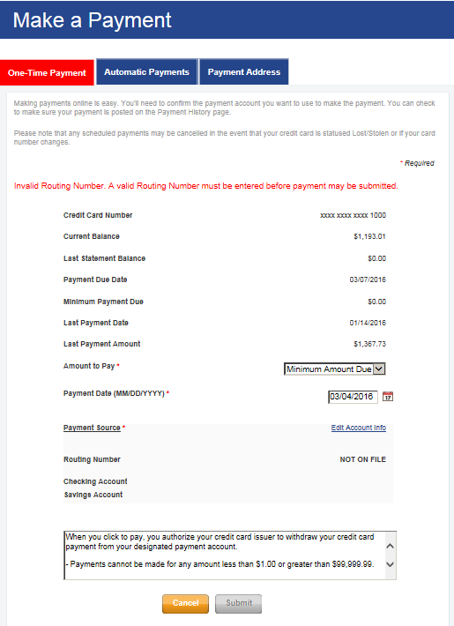
- What is the payment address?
VISA
PO BOX 37603
Philadelphia, PA 19101-0603

- How can I view my payment history?
  - Select “Payments” and click on “Payment History”
  - Payment history reflects payments made to the card account regardless of whether the payment was made online, by mail, or at the branch.
  - Cardholders may cancel payments with a “Scheduled” status.
  - Payments with an “In Process” or “Posted” status can’t be cancelled
  - Payments processing that day will not display in Payment History.
- How can I view my existing cards and add additional cards to this account view?
  - Select “Services” and “Manage Cards”
  - From this screen members can order replacement cards, remove existing cards from this profile and add additional cards
  - Members who are earning rewards can also see the reward balance directly from this screen
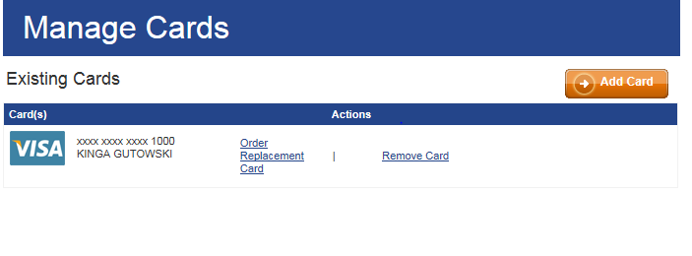
- How can I setup alerts on my credit card?
  - To setup alerts, select “Communication” and click on “Member Alerts”
  - From the next screen, select “Member Alerts”
  - Member receives disclaimer that receiving alerts is helpful to detect fraud and keep the account safer
  - After clicking “Submit”, member is redirected to Member Alerts website where he or she can enroll and manage alerts
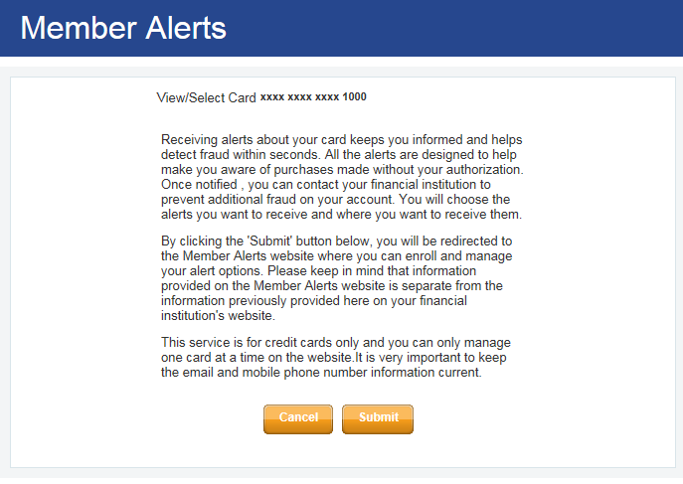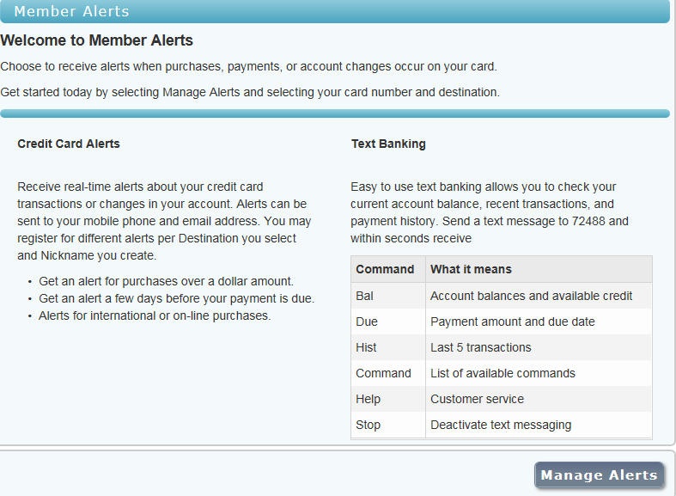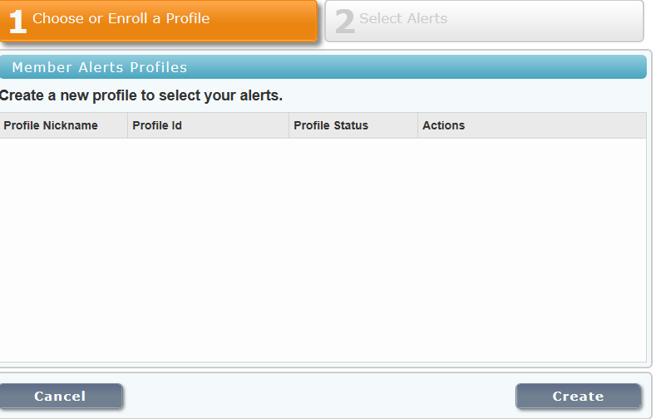
  - After clicking “Submit”, select “Create” from the next screen
  - Member must select Alert method
    - Email
    - Mobile
  - Must give this alert registration a nickname
    - Nickname will appear with your alert
    - Nicknames are limited to 10 characters and should not be the member’s last name
  - Member may setup Purchase alerts
    - Transactions greather than $(20-99,999)
    - International Transactions
  - Member may setup Account Notifications
    - Payment Due Date reminder
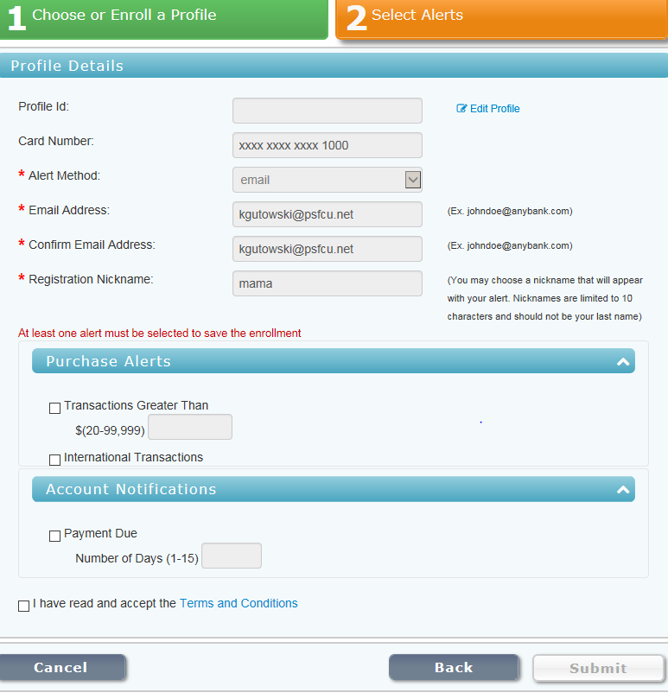

- ADDITIONAL INFORMATION
  - One the home page, there are Quick Links providing additional information about a service or a shortcut to perform most frequently performed transactions

